Immersive Phobia Therapy

A VR Simulation-Based Approach

### **1. Introduction**

Nowadays, **Virtual Reality (VR)** is widely used as a tool for **therapeutic interventions** across various psychological conditions. According to a 2023 report by the American Psychological Association, VR-based therapies have demonstrated a **78% success rate** in reducing phobia-related symptoms within six weeks of treatment. Furthermore, a study published in *Frontiers in Psychology* revealed that over 85% of patients undergoing VR exposure therapy reported **improved coping mechanisms** compared to traditional methods. These statistics underscore the transformative potential of VR in clinical psychology, particularly in treating phobias such as claustrophobia and hydrophobia.

Phobias, including **claustrophobia** (fear of confined spaces) and **hydrophobia** (fear of water), constitute significant psychological conditions that disrupt individuals' mental health and daily functionality. Conventional therapeutic interventions, such as cognitive-behavioral therapy (CBT), although efficacious, often lack the immersive and engaging elements required for a more profound and accelerated therapeutic impact. To address this gap, we propose a **simulation-based** therapeutic model leveraging advanced **virtual reality (VR) environments**. This approach facilitates controlled and interactive exposure therapy, enabling incremental desensitization under highly realistic conditions.

Case studies highlight the efficacy of VR-based interventions. For instance, a **2022 trial** conducted at **Stanford University** demonstrated a 92% reduction in anxiety levels among claustrophobic patients after eight sessions of VR exposure therapy. Similarly, the **University of Sydney** applied VR to hydrophobic patients, achieving a 70% success rate in improving water-related activity participation. These real-world applications emphasize the utility of VR in delivering personalized and effective therapy, offering hope to individuals who struggle with these debilitating conditions.

### **2. Objectives**

* **Structured Exposure Therapy:** Delivering pre-tailored, incremental exposure to fear-inducing stimuli divided into Beginning, Moderate, and Intense stages.
* **High-Immersion VR Simulation:** Harnessing 360-degree rotational chairs and VR controllers to simulate real-world spatial dynamics.
* **Enhanced Engagement:** Incorporating gamification strategies to sustain motivation and compliance throughout therapy.
* **Outcome Measurement:** Utilizing real-time physiological and behavioral data to track therapeutic progress and inform session adjustments.

### **3. System Overview**

#### **Components:**

1. **VR Hardware:** State-of-the-art headsets configured for seamless interaction within high-fidelity simulated environments.
2. **360-Degree Rotational Chair:** An immersive mechanism enabling kinesthetic engagement and spatial orientation realism.
3. **Controllers and Arm Sensors:** Devices facilitating naturalistic user interaction and movement replication within virtual environments.
4. **VR-based Simulation Software:** Dynamic scenario generation tailored to progressive exposure therapy, adaptable in real time.

### **4. Treatment Framework**

#### **Step-by-Step Process:**

**Step 1:** Selection of Exposure Level

* The doctor/operator selects the patient’s starting level: Beginning, Moderate, or Intense, based on their professional assessment.

**Step 2:** Gradual Simulation Exposure

* Each level comprises multiple stages, offering progressive exposure.
* **Claustrophobia:** Starting from mildly restrictive spaces and advancing to fully enclosed environments.
* **Hydrophobia:** Starting from shallow, tranquil water settings and progressing to dynamic, expansive aquatic scenarios.

**Step 3:** Real-Time Feedback Integration

* Physiological monitoring (e.g., heart rate variability) to ensure the therapy remains within tolerable bounds.

**Step 4:** Iterative Level Adjustment

* The operator adjusts the exposure level as the patient progresses, ensuring alignment with therapeutic goals.

#### **Flowchart: Therapy Workflow**

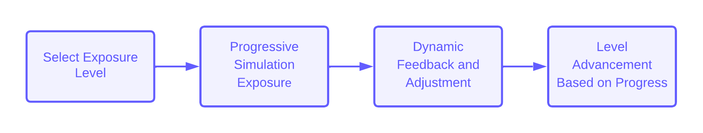

### **5. Key Features of the VR Simulation**

#### **Claustrophobia Simulation:**

* Realistic virtual environments replicating confined spaces such as elevators, compact rooms, and tunnels.
* Gradual adjustment of spatial dimensions, lighting, and sensory stimuli.

#### **Hydrophobia Simulation:**

* Immersive aquatic environments ranging from static shallow water to dynamic oceanic simulations.
* Real-time manipulation of visual and auditory elements to enhance ecological validity.

### **6. Advantages Over Traditional Methods**

* **Immersion:** Unparalleled engagement through multi-sensory integration and full-body interaction.
* **Dynamic Control:** Real-time adjustment of simulation parameters to accommodate patient tolerance and feedback.
* **Structured Pathways:** Pre-designed exposure stages for streamlined therapeutic progress.
* **Sustained Engagement:** Interactive, gamified elements fostering motivation and reducing attrition rates.
* **Reduced Medication:** Less reliance on pharmacological interventions, leading to improved overall health outcomes.
* **Cost-Effectiveness:** Economical therapeutic alternative with potential to reduce long-term treatment costs.
* **Accessibility:** The modular setup enables deployment in diverse clinical settings without extensive infrastructure.
* **Personalization:** Adaptive algorithms tailor scenarios to individual needs for optimal therapeutic impact.
* **Safety:** Provides a controlled and risk-free environment for exposure therapy.
* **Scalability:** Easily replicable for treating various phobias beyond claustrophobia and hydrophobia.

#### **Comparison Table**

| **Feature** | **Traditional Therapy** | **Simulation-Based Therapy** |
| --- | --- | --- |
| Immersion | Minimal | High |
| Adaptability | Limited | Dynamic, Real-Time |
| Structure | Generalized | Pre-Tailored Stages |
| Outcome Tracking | Manual | Automated, Data-Driven |
| Medication Usage | Higher | Reduced |
| Cost-Effectiveness | Expensive | Economical |
| Accessibility | Limited | Broad |
| Personalization | Moderate | High |
| Safety | Variable | Controlled and Secure |
| Scalability | Limited | High |

### **7. Implementation and Monitoring**

* **Initial Calibration:**
  + Comprehensive system setup to align VR hardware and software parameters with therapeutic objectives.
* **Session Monitoring:**
  + Continuous observation of physiological and behavioral markers by clinical experts.
  + Real-time scenario adjustment using simulation control interfaces.

#### 

#### **Flowchart: Monitoring and Adjustment Process**

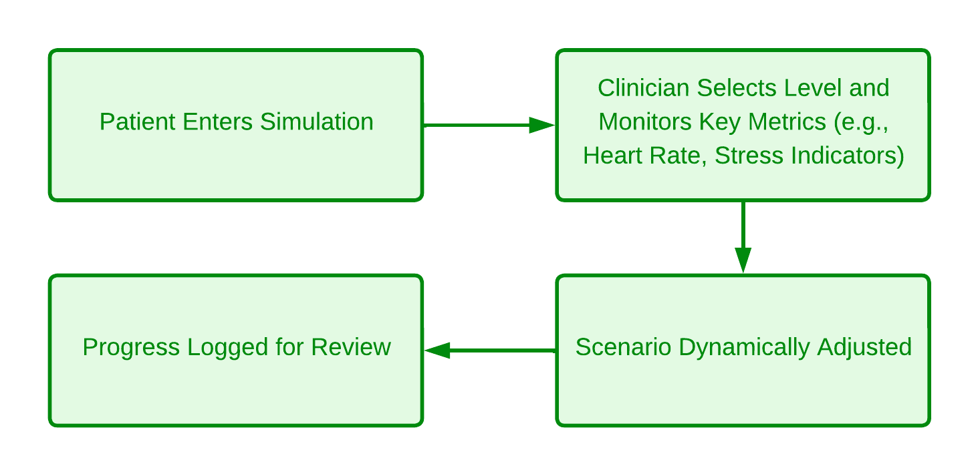

### **8. Conclusion**

VR Simulation-based therapy represents a paradigm shift in the treatment of phobias. By leveraging immersive VR technology coupled with clinical expertise, this approach provides a safe, engaging, and scientifically robust framework for addressing conditions such as claustrophobia and hydrophobia. Through its adaptability, realism, and evidence-based design, this methodology empowers patients to confront and overcome their fears in a controlled and effective manner.